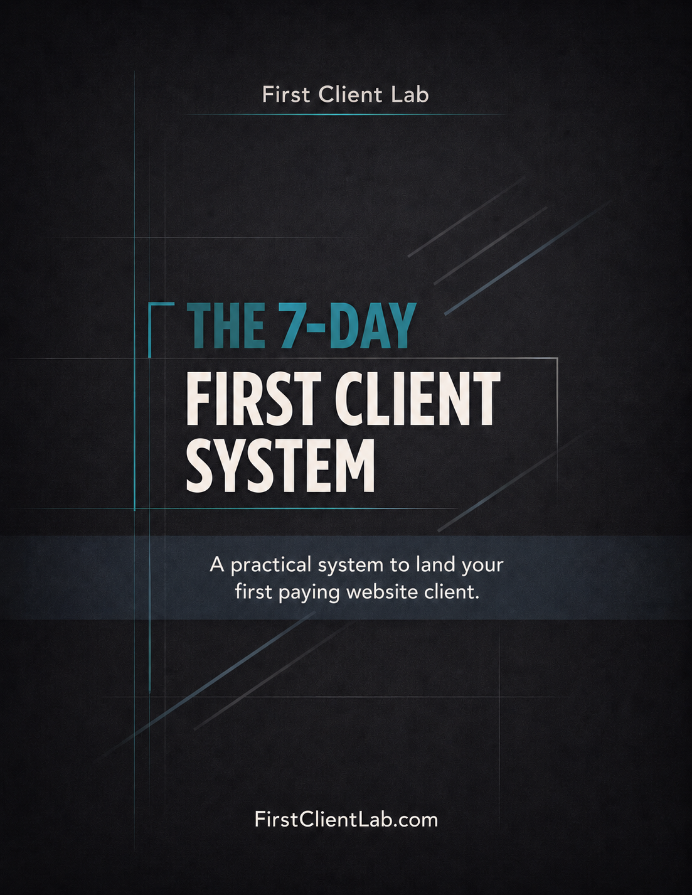
Land Your First Paying Website Client in 7 Days
Even if you have no portfolio, no experience closing deals, and no idea how to sell.
Promise: Pick one simple website offer, send focused outreach, book conversations, and close your first paid project.
You are one conversation away from your first client.
This system is designed to create that conversation fast.

Inside This System
- 3 simple website offers
- Copy/Paste outreach scripts
- No-portfolio demo method
- Discovery call structure
- 7-day action plan
- Daily tracking system
- Lead Tracker (Spreadsheet – Included tool)
- Track Leads
- Messages sent
- Replies
- Calls
- Closed deals

Most people fail because they don’t track activity. This keeps your outreach consistent.

Who This Is For
- You can build basic websites or landing pages, but you have not monetized the skill yet.
- You do not have a strong portfolio and need a shortcut to proof.

The Core Rule
Do not build another app before making offers. Paid projects come from clear offers, targeted businesses, conversations, and follow-up.
- You want a simple daily plan instead of another long course.

Complete each section in order. Do not skip ahead. Every part builds on the previous one.

Part 1 - Pick One Offer (5 minutes)
Offer | Positioning | Starter Price | Best For
Starter Website | Simple, modern 1-page website that helps customers understand and contact the business fast. | $500-$900 | Businesses with no website
Website Redesign | Clean up an outdated site so it looks more trustworthy and turns visitors into leads. | $800-$1,500 | Businesses with old, confusing, or weak mobile sites
Website Care Plan | Monthly updates, small edits, and basic improvements so the owner does not touch the site. | $150-$350/mo | Recurring income after a project
Recommended first offer: Website Redesign. It is easier to prove because you can show old vs. improved.

Part 2 - Build the Target List (30-45 minutes)
- Search Google Maps and Instagram for local businesses.
- Start with barbershops, restaurants, contractors, HVAC, plumbing, cleaning, landscaping, med spas, and real estate agents.
- Add a lead when the site is missing, outdated, slow, confusing, or weak on mobile.

Part 3 - No-Portfolio Demo Hack (60-90 minutes)
- Pick one business from the lead list.
- Rebuild only the top section of their homepage: headline, hero image area, services, contact button.
- Screenshot your version.
- Use it as proof with the line: “I put together a quick visual idea for how your site could look cleaner and make it easier for customers to contact you.”

Part 4 - Outreach Scripts (30-45 minutes/day)

Instagram DM 1
Hey — quick question. I came across your business and noticed your website could be doing a better job turning visitors into calls. I build simple, modern websites for local businesses. Would you be open to a quick idea I had for yours?

Instagram DM 2
Hey, I checked out your site and noticed a few easy fixes that could make it look more trustworthy on mobile. I can send a quick redesign idea if you want.

Cold Email
Subject: Quick website idea
Hey, I came across your business and had a quick idea for your website. I build simple website redesigns for local businesses that want more calls and leads. I noticed a few things that could be improved quickly. Want me to send the idea over?

Follow Up 1
Just following up on this. I can send a quick visual idea, no pressure.

Follow Up 2
Totally understand if now is not the right time. If you ever want a cleaner site that makes it easier for customers to contact you, I can help.

Part 5 - Discovery Call Script
- Opening: Thanks for taking a few minutes. I want to understand what you need and see if I can actually help.
- Question 1: What do customers usually come to you for?
- Question 2: Where do most leads come from right now?
- Question 3: What do you dislike about the current website?
- Question 4: What action should visitors take?
- Question 5: If we fix these problems, what would success look like for you?
- Close: Based on what you said, I recommend a simple redesign focused on mobile trust, clear services, and stronger contact flow.

Part 6 - 7-Day Action Plan
Day | Action
1 | Pick the Website Redesign offer and build one demo.
2 | Build a list of 50 local businesses.
3 | Send 20 messages.
4 | Send 20 more and follow up with Day 3 leads.
5 | Send 20 more and book calls.
6 | Send proposals to interested leads.
7 | Close one project or continue the loop until one closes.

Daily Scorecard
- Messages sent: ____
- Replies: ____
- Calls booked: ____
- Proposals sent: ____
- Closed projects: ____

Common Mistakes
- Building a portfolio for months
- Sending one message and quitting
- Targeting businesses that already have a great, functional website
- Talking about technology instead of business results

Final Rules
- Do not redesign this system before using it.
- Do not wait for perfect branding.
- Send 100 messages before deciding what does or does not work.
- A paid project is better than a perfect portfolio.

If you follow this exactly, you will get replies.
If you get replies, you will get conversations.
If you get conversations, you will close a client.
Your only job is to send the messages.

Recommended Free Tools
- Design
- Figma
- Canva
- Hosting
- GitHub Pages
- Firebase Hosting
- Domain
- Namecheap
- Finding Businesses
- Google Maps
- Instagram
- Facebook Marketplace
- Tracking
- Included CRM (Lead Tracker)

